GLOBAL TAG BLE DEVELOPMENT KIT
Beacon with sensors + accessories
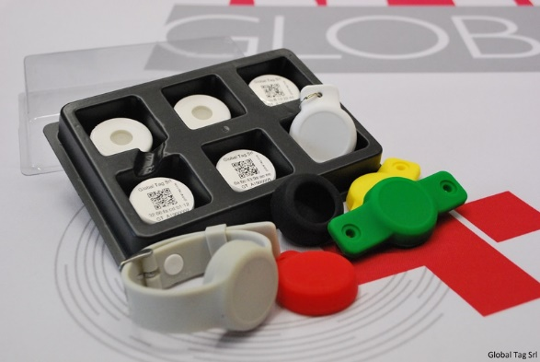

Global Tag BLE DEVELOPMENT KIT is a BLE (Bluetooth Low Energy) Beacon kit proposed to test Beacons and to develop BLE App/SW.

It’s composed by DISK BEACONY with integrated Temperature/Humidity sensor and accelerometer.

Silicone housings (Keyfob, Wall Mount, Watchcase and Wristband) are included to meet different application areas.

Devices are supplied with CR2032 battery (DURACELL®), which can be easily replaced thanks to the snap open/close system of the plastic case.
Detection range reaches up to 200 meters.

iBeacon and Eddystone (UID, TLM, URL) protocols are available, and Beacons can operate with iOS 7.0 and Android 4.3+ system.

The BLE Development Kit also includes Demo APP for Android, technical parameters and SDK for APP Android and IOS development, PDF user guide

COMPOSITION:
DISK BEACONY (quantity as below described) WITH INTEGRATED TEMPERATURE/HUMIDITY SENSORS AND ACCELEROMETER with chip NRF52810.
(Dimensions: Ø31mm diameter / Ø1,22in diameter Thickness: 10mm / 0,334in)
1pc. Wall Mount accessory
1pc. Keyfob accessory
1pc. Protection case
1pc. Wristband accessory
1pc. Suction cup accessory
Technical support by phone and e-mail and technical documentation
DEMO APP software to test main beacon functions. (for more information please visit our website)

CHOICE QUANTITY OF BEACON TO PLACE ORDER:
3pcs. Beacon with sensors € 70,00 (including shipping fee)

5pcs. Beacon with sensors € 100,00 (including shipping fee)

10pcs. Beacon with sensors € 150,00 (including shipping fee)

FORM TO PLACE ORDER:
COMPANY NAME: ______________________________________________________________________
NAME AND SURNAME: __________________________________________________________________
E-MAIL ADDRESS: _______________________________________________________________________
INVOICE ADDRESS: ______________________________________________________________________
DELIVERY ADDRESS: _____________________________________________________________________
CITY: _________________________________________________________________________________
COUNTRY: _____________________________________________________________________________
VAT N.: _______________________________________________________________________________
Please, send the filled form at: sales@global-tag.com

DISCLAIMER
The information in this document is subject to change without notice. Global Tag assumes no responsibility for any errors that may appear in this document.
Application recommendations are guidelines only - actual results may vary and should be confirmed. This is a general purpose product not designed or intended for any specific application.
Global Tag Srl or its subsidiaries are not responsible for the performance or support of third party products and does not make any representations or warranties whatsoever regarding quality, reliability, functionality, or compatibility of these devices or products.

© Copyright 2019 - Global Tag Srl

